1. 
2. 
3. Let’s see when we need idempotent consumer.
4. 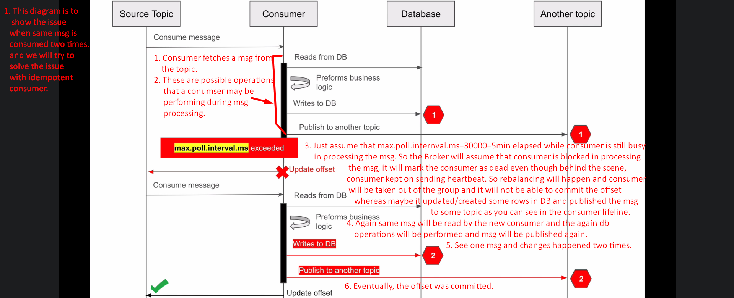
5. 
6. The following diagram to show how to make a consumer IDEMPOTENT.
7. Skipped.